**Project name is – ‘Find Training Course’**

**STATIC REVIEW**

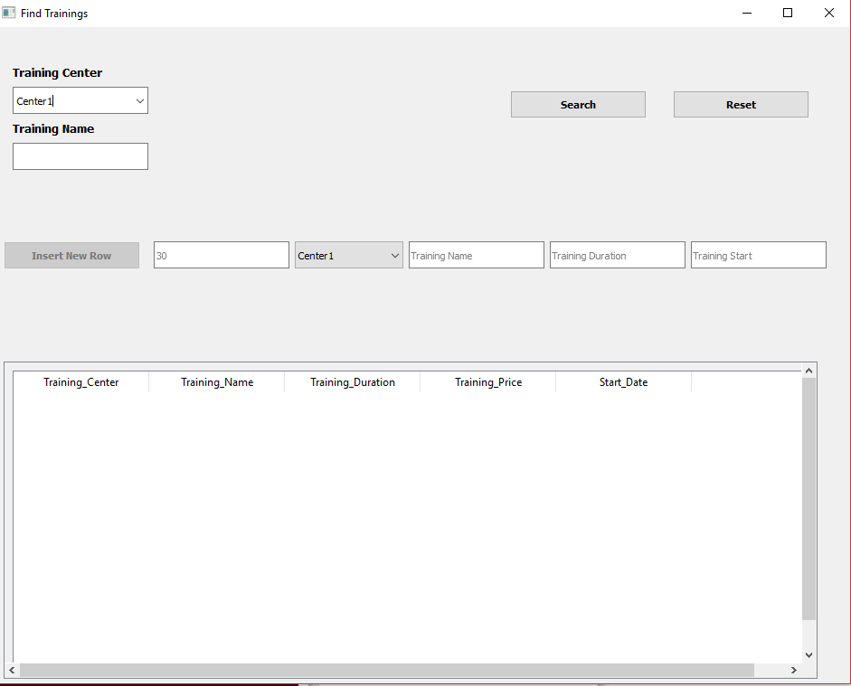

**Gather all suggestions:**

1. The “Training Center” field will have a “pop up” that will describe all the services in detail and the same “pop up” for the “Training Name” where information about teaching coaches can be found.
2. The * symboll must be on the required fields.
3. Let`s add additional “Free” and “Paid” fields, where only the paid and free courses will be seen.

**Find bugs:**

1. Project name is- “Find Training Course” but in mockup is “Find Training” 
2. There is a mistake in the text of the first requirement: UI should contains Training Center and Trayning Name fields for search. It should be”Training”.
3. According to 4, 5 and 6 requirements:

* “Inserted training should minimum has id,”
* “User can see the duration of training via start and end dates”
* “Find Training Course project should have delete ability for closed training”

but “ID”, “End dates” and “Delete ability” are missing from the mockup.

1. Does not require anything to say about “Training-Price”, but it is available in the mockup.



1. The fields of the same line must be the same:



**Do requirement clarification:**

1. When the user indicates “Start” and “End” of the date, how can user understand that the lessons are convenient for him/her according to the frequency.
2. Maybe we should clarify  field and give a clear name so that the user understands.
3. How will it be implemented ” Find Training Course project should have delete ability for closed training” , how understandable and useful it is.